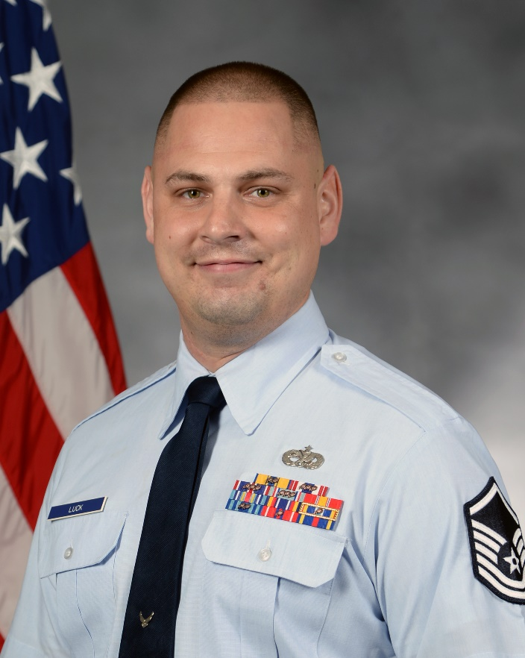**MASTER SERGEANT EDWIN A. LUCK**

MSgt Edwin A. Luck is the Detachment Superintendent, 373 Training Squadron, Detachment 11, Offutt AFB, Nebraska. He leads a 16 instructor maintenance training team that qualifies and trains over 500 personnel across 3 MAJCOMs annualy utilizing 48 aircraft courses. He oversees detachment production for host-demanded technical support in maintaining ()C-135 and E-4B aircraft. In addition, Seargeant Luck is the Air Education and Training Command’s focal point coordinating with MAJCOMs and host units creating Mainenance training plans to meet changing mission requirements.

Sergeant Luck grew up in Salt Lake City, Utah and entered the Air Force in July 2003. Throughout his career he has filled numerous roles within the aircraft maintenance enterprise supporting the E-3 Airborn Warning And Control Systems, B-1B Lancer, E-4B National Aiarborn Operations Center, and the (R)C-135’s 9 diffrent veriants. Additionally, Sergeant Luck has held numerous leadership positions in technical military education such as Aircraft Maintenence Technical Training Instructor, Instructor Supervisor and now Detachment Superintendent for the 373d training squadron, Detachment 11.

Prior to his selection to his current position, Sergeant Luck served as a Flightline Expediter for the 37th Aircraft Maintenace Unit at Ellsworth AFB, South Dakota.

**EDUCATION**

2007 Airman Leadership School, Tinker AFB, Okla.

2010 Associates Applied Science Aviation Maintenance Techecnoloogy, Community College of the Air Force

2010 Associate Applied Science Instructor of Technology & Military Science, Community College of the Air Force

2012 Occupational Instructor and Master Instructor Certifications, Community College of the Air Force

2013 Senior Enlisted Joint Professional Military Education, Tinker AFB, Okla., by correspondence (Legacy Course)

2014 Non-Commissioned Officer Academy, Peterson AFB, Colo.

2015 Senior Non-Commissioned Officer Course 14, Ellsworth AFB, S.D., by Correspondence

2016 Professional Manager Certification, Community College of the Air Force

2017 Bachelors of Science, Management, National American University, S.D

**ASSIGNMENTS**

1. November 2003 - October 2009, E-3 Dedicated Crew Chief, 552 MXS, Tinker AFB, Okla.

2. October 2009 - September 2013, Instr, Strategic Acft Maintenance, 373 TRS/DET 9, Tinker AFB, Okla.

3. September 2013 - January 2014, B-1 Dedicated Crew Chief, 28 AMXS, Ellsworth AFB, S.D.

4. January 2014 - October 2015, Aircraft Section NCOIC, 28 AMXS, Ellsworth AFB, S.D.

5. October 2015 - January 2017, Aircraft Section Chief, 28 AMXS, Ellsworth AFB, S.D.

6. January 2017 - April 2018, Flightline Expediter, 28 AMXS, Ellsworth AFB, S.D.

7. April 2018 - Current, Detachment Chief, 373 TRS/DET 11, Offutt AFB, Neb.

**MAJOR AWARDS AND DECORATIONS**

Meritorious Service Medal

Air Force Commendation Medal with two oak leaf clusters

Meritorious Unit Award with three oak leaf clusters

Outstanding Unit Award with three oak leaf clusters

Global War On Terrorism Expeditionary Medal

Global War on Terrorism Service Medal

**OTHER ACHIEVEMENTS**

2018 Detachment Chief of the Quarter

2016 AMU SNCO Lt Gen Leo Marques

2016 NCO of the Quarter

2011 Instructor of the Quarter

**EFFECTIVE DATE OF PROMOTION**

Master Sergeant April 1, 2016

(Current as of December 2018)